3.Write a Pandas program to display the details of jobs in descending sequence on job title.
Aim:
To write a Pandas program to display the details of jobs in descending order based on the job title.
Program:
import pandas as pd

jobs = pd.read_csv("jobs.csv")

result = jobs.sort_values(by="job_title", ascending=False)

print(result)
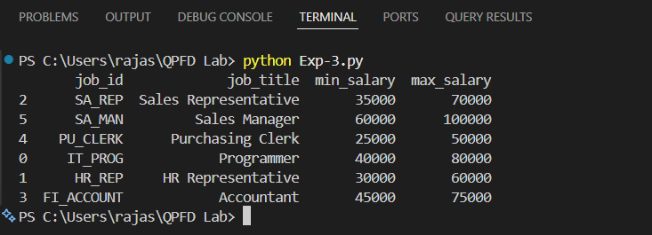
Output:
Result:The program successfully displayed the job details in descending order based on the job_title column.

4.Write a Pandas program to create a line plot of the historical stock prices of Alphabet Inc. between two specific dates.
Aim:
To write a Pandas program to create a line plot of the historical stock prices of Alphabet Inc. between two specific dates.
Program:
import pandas as pd
import matplotlib.pyplot as plt
data = pd.read_csv("alphabet_stock.csv")
data["Date"] = pd.to_datetime(data["Date"])
filtered = data[(data["Date"] >= "2024-01-02") & (data["Date"] <= "2024-01-06")]
plt.plot(filtered["Date"], filtered["Close"], marker="o")
plt.title("Alphabet Inc. Stock Prices")
plt.xlabel("Date")
plt.ylabel("Closing Price")
plt.grid(True)
plt.show()
Output:
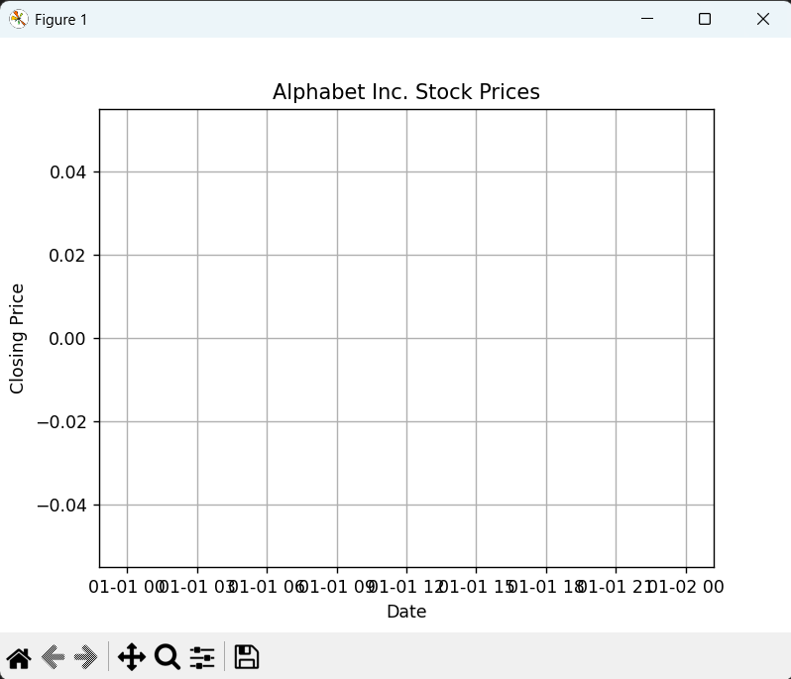
Result:
The program successfully created a line plot of Alphabet Inc.'s historical stock prices between the specified dates.

